导流罩业绩表
Nozzel Achievement
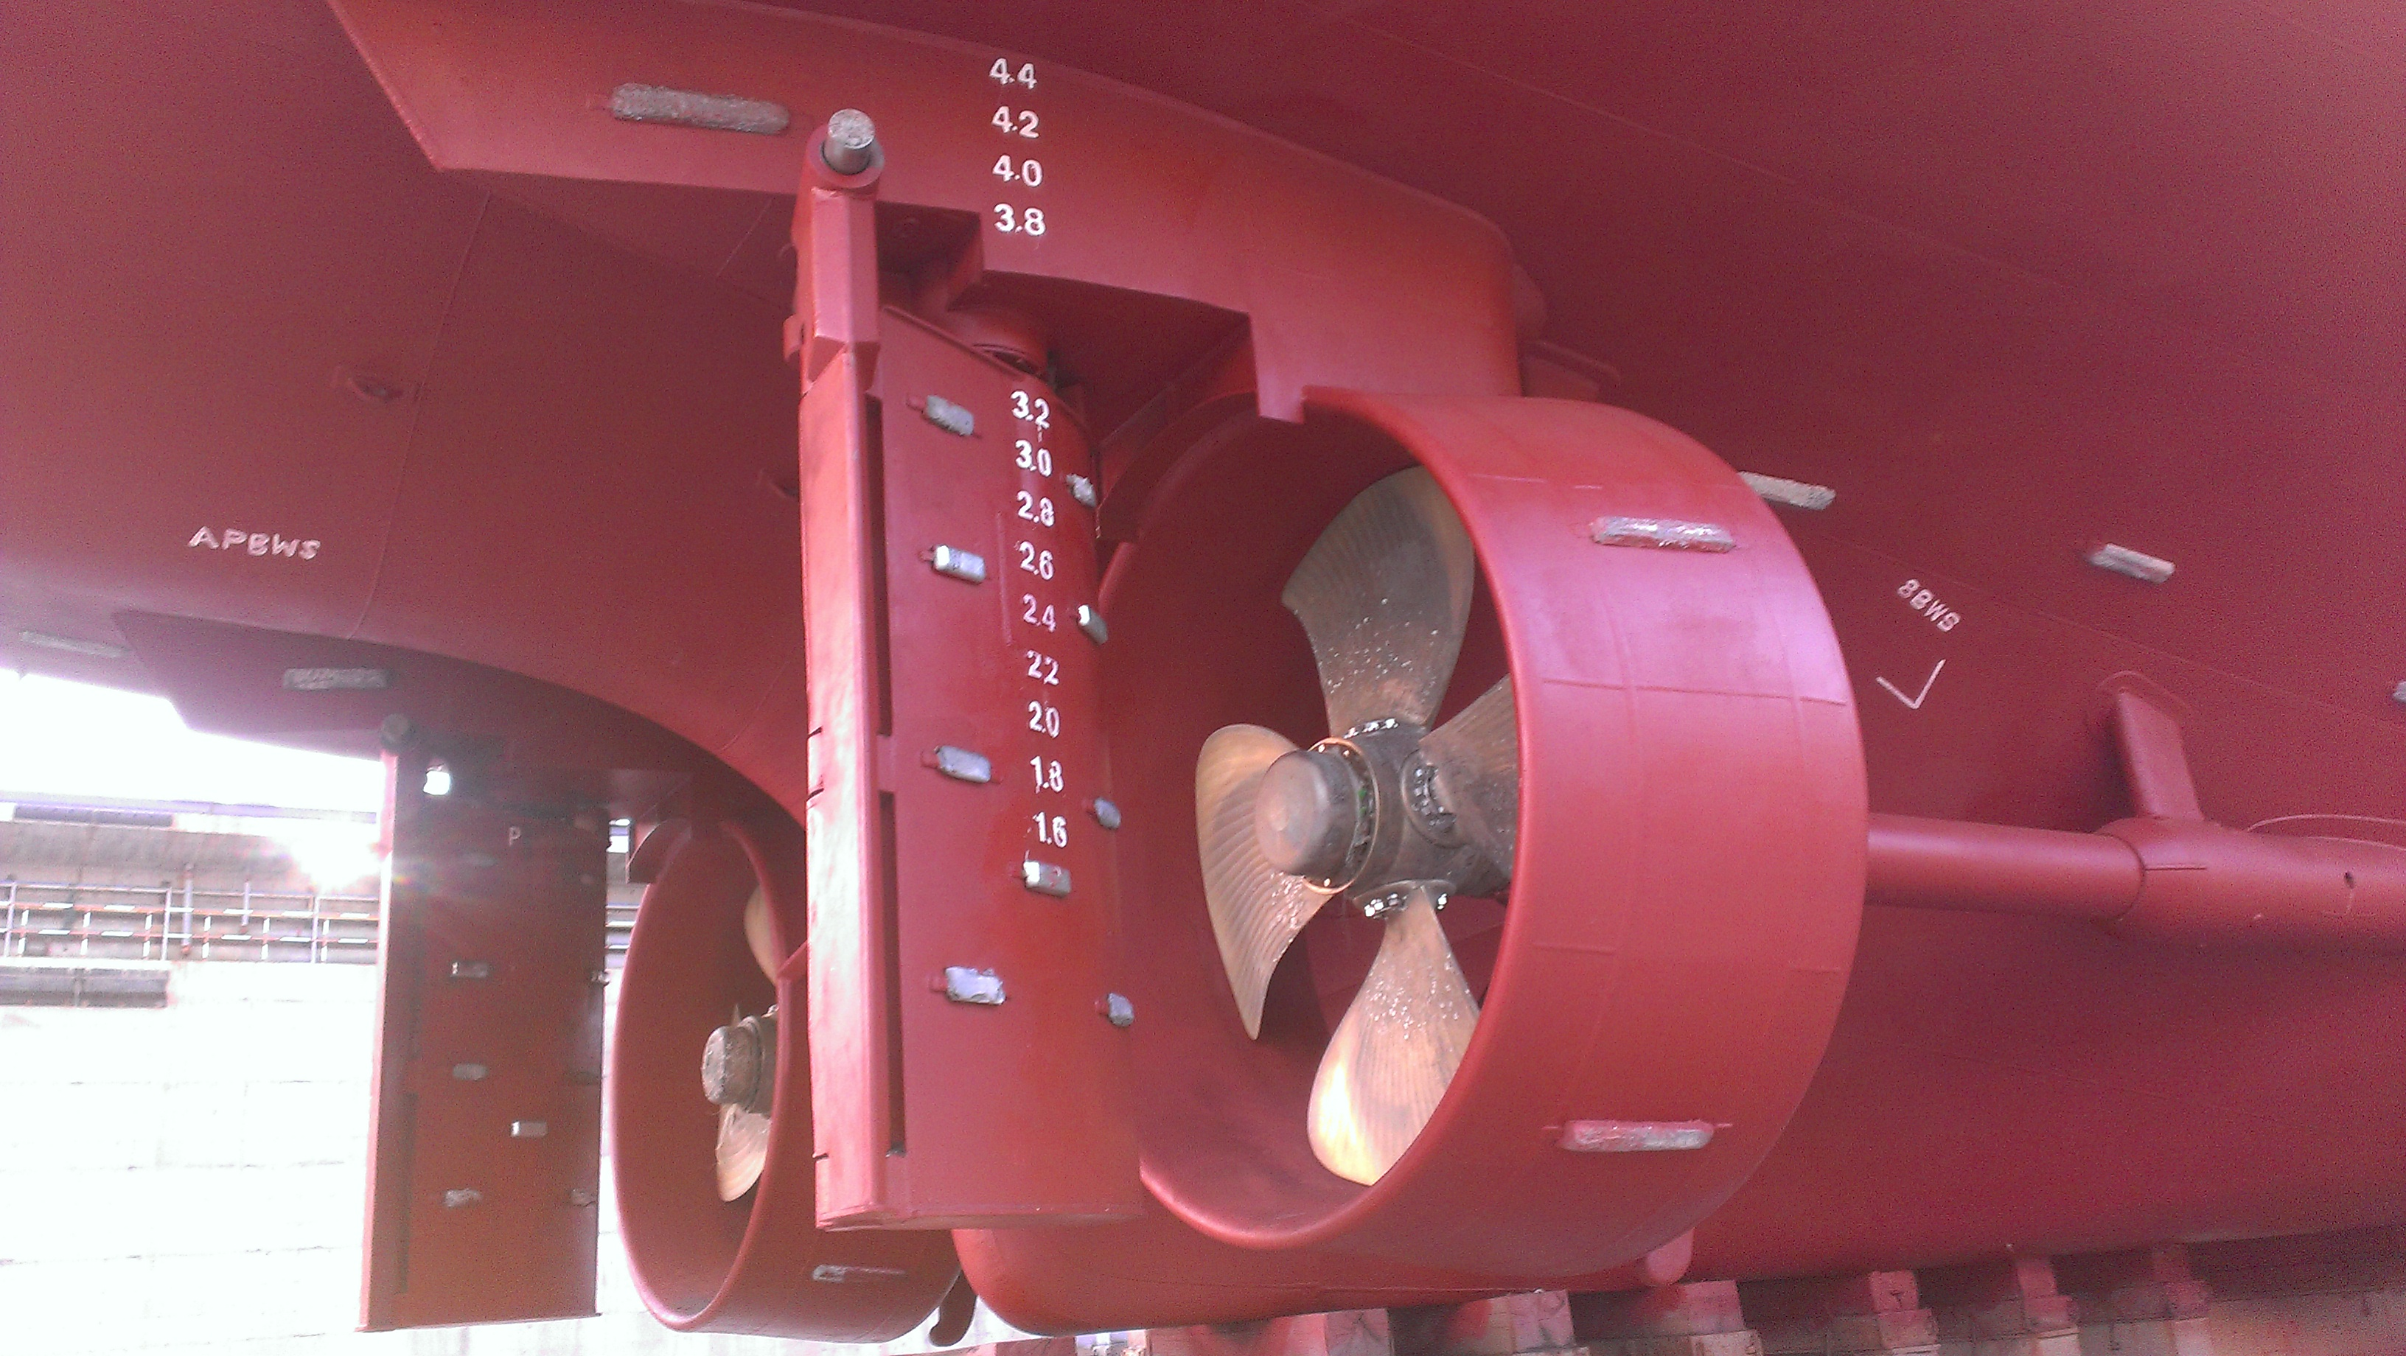

无锡市东舟船舶设备股份有限公司
WUXI DONGZHOU MARINE EQUIPMENT CO.,LTD.

No | SHIPYARD  船厂 | PROJECT  项目 | CLASS  船级社 | PRODUCT  产品 | Qty(set/ship) 数量 | REMARK  备注
 | Guangdong Jiangmen Hongda Shipyard  广东江门鸿达船厂 | 59m AHTS  59m 三用工作船 | ABS | Nozzel  导流罩 | 18
 |  | 65m AHTS  65m 三用工作船 | ABS | Nozzel  导流罩 | 8
 | Shanghai Shipyard  上海船厂 | 12000HP AHTS  12000HP 三用工作船 | CCS | Nozzel  导流罩 | 8
 | Wuchang Shipyard  武昌船厂 | 12000HP AHTS  12000HP 三用工作船 | CCS | Nozzel  导流罩 | 8
 | Shanghai Zhenhua Shipyard  上海振华船厂 | 64.8M oil platform accommodation vessel  64.8m油田平台交通船 | CCS | Nozzel  导流罩 | 6
 | No3 Engineering Company Lid .Of cccc Firsh Harbor Engineering Company Ltd  中交一航局第三工程公司 | 2940 KW Tug  2940 KW 拖轮 | CCS | Nozzel  导流罩 | 4
 | Wuhu Xinlian Shipyard  芜湖新联 | 78m AHTS  78m 三用工作船 | ABS | Nozzel  导流罩 | 4
 | PT ASL Shipyard | 65m AHTS  65m三用工作船 | ABS | Nozzel  导流罩 | 10
 |  | 59m AHTS  59m三用工作船 | ABS | Nozzel  导流罩 | 10
 | 中船黄埔文冲船舶有限公司  Guangzhou CSSC Huangpu Shipyard Co.,Ltd | 7800kW绞刀功率自航绞吸挖泥船  7800KW dredger | CCS | Nozzel  导流罩 | 2
 |  |  | 合计 |  | 78

