艉滚筒业绩表
stern rollerAchievement

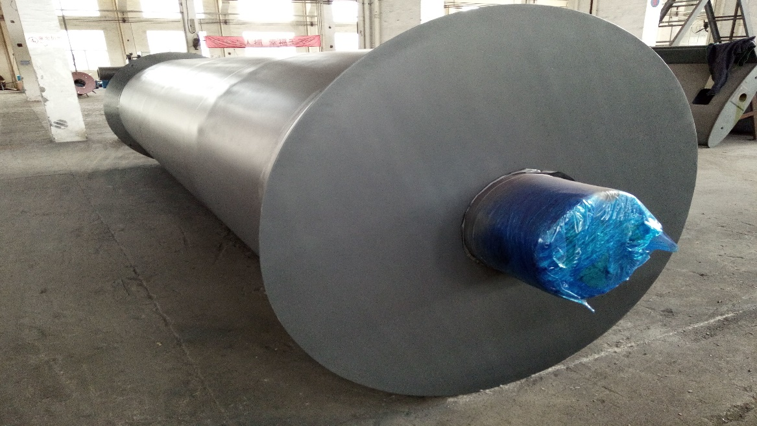

无锡市东舟船舶设备股份有限公司
WUXI DONGZHOU MARINE EQUIPMENT CO.,LTD.

No | SHIPYARD  船厂 | PROJECT  项目 | CLASS  船级社 | PRODUCT  产品 | Qty(set/ship) 数量 | REMARK  备注
1 | Guangxin Shipbuilding & Heavy Industry Co., Ltd..  广机海事重工股份有限公司 | 8000HP AHTS  8000HP破冰型三用工作船 | CCS | stern roller  艉滚筒 | 4
2 | Shanghai Zhenhua Heavy Industries Co.,Ltd  上海振华重工（集团）股份有限公司 | 6500HP AHTS  6500HP油田守护供应船 | CCS | stern roller  艉滚筒 | 6
3 | PaxOcean Engineering Zhuhai Co.，Ltd  珠海太平洋粤新海洋工程有限公司 | 64m AHTX | ABS | stern roller  艉滚筒 | 6
4 | Guangdong Jiangmen Hongda Shipyard  广东江门鸿达 | 59mAHTS | ABS | stern roller  艉滚筒 | 9
5 | PT ASL Shipyard  印尼ASL | 59m AHTS | ABS | stern roller  艉滚筒 | 5
6 | Jiangsu Dajing Shipyard  江苏大津重工有限公司 | 8000HP AHTS | CCS | stern roller  艉滚筒 | 2
7 | Hudong-Zhonghua Shipbuilding (Group) Co., Ltd  沪东中华造船集团有限公司 | 3000T fishery administration vessel  3000T渔业资源调查船 | ZY | stern roller  艉滚筒 | 6
8 | Jiangnan Shipyard  江南造船（集团）有限责任公司 | Polar scientific survey ship  极地科学考察破冰船 | CCS | stern roller  艉滚筒 | 3
9 | Jiangsu Dajing Shipyard  江苏大津重工有限公司 | Multi-Purpose Icebreaking Tug | RMRS | stern roller  艉滚筒 | 1
 |  |  | 合计 |  | 42套

